CHURCH INFORMATION

35225 Avenue E, Yucaipa, CA 92399 www.yucaipasda.com
Phone (909) 797-1375 Fax (909) 797-2705

Office Hours - Tuesday through Thursday from 9 am to 1 pm
Pastoral appointments are available as needed
Secretary – Denise Noble cdnoble@verizon.net

PASTORAL STAFF

The pastors are here to serve you. Please call whenever you or a loved one must go into the hospital or needs crisis counseling. We are here to help you!

Senior Pastor – Hein Strydom
9628 Terra Linda Way, Calimesa, CA 92320
(909) 954-7512 hdstrydom@netscape.net

Pastor for Worship – Elijah Grekov
(909) 795-6965 elijahgrekov@gmail.com

Young Adults Pastor – William Hunt
(210) 778-6502 huntwr@msn.com

Family Ministries Coordinator - Jennifer Lidar (909) 528-9866

Children’s Church Coordinator - Yvonne Wren (909) 797-7923

Youth Ministries Coordinator - Matthew Burton
(909) 747-9953 revive.yucaipasda@gmail.com

Church Treasurer – Linda Hill (909) 797-0487

Head Elder – Dallas Bobst (951) 845-2394

Head Deacon – John Decker (909) 374-1031

Head Deaconess – Gloria Pohren (909) 797-1714

Church Maintenance – John Decker (909) 374-1031
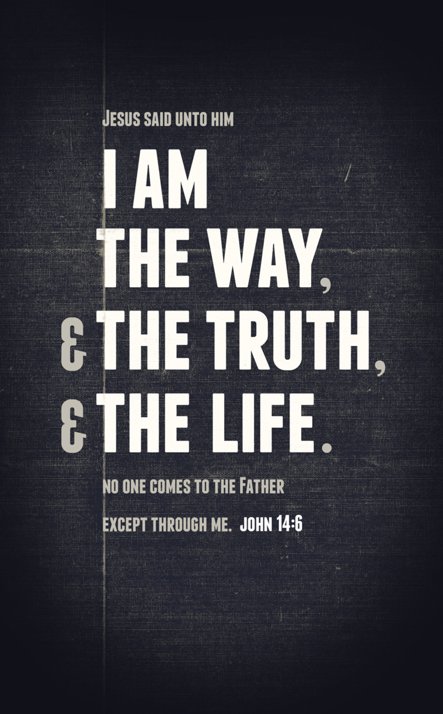
CONNECT

Thank you for joining us on this beautiful Sabbath day! We are delighted for the opportunity to praise and worship together. Everyone is invited to join us each Sabbath morning at 11 am in the Youth Center at the Yucaipa Seventh-day Adventist Church.
www.facebook.com/crossconnectionyucaipa
crossconnectionyucaipa@gmail.com

SABBATH SCHOOL ACTION GROUPS
Overflow room –
Ardyce Fowler, Clyde Williams
Elders’ Room –
Joyce Hopp, Don Martin, Christine Neish
Community Services –
Dan Buckendahl, Laurel Slater, Dorothy Womack
Sanctuary, front center –
Peggy Tomat, Bette Husted, Eleanor Dosey
Fellowship Hall –
Gary Strunk, Bob Cash, Tony Venckeleer
Board Room –
Tim Chapman, Trish Chapman
Former Music Room –
Young Adults (Backstage Hallway) Ages 18 to 35

CHILDREN & YOUTH SABBATH SCHOOL
North Patio – Cradle Roll, Ages 0 to 3
Northeast Patio – Kindergarten, Ages 4 to 6
East Patio – Primary, Ages 7 to 9
East Patio – Juniors, Grades 5 and 6
Family Ministries Room – Earliteens, Grades 7 and 8
Youth Center, South Patio – Revive, Grades 9 to 12

SMALL GROUP STUDIES

Small group Bible studies are happening each Monday at 6:30pm at Brian and Marise Doty’s home (12300 5th St. #15, Yucaipa), every Friday at 7:00pm at Pastor Bill and Audrey Hunt’s home (10830 Pepper Way, Loma Linda) and a youth study each Monday at 6:30pm in the Youth Chapel.
CROSS CONNECTION
AT YUCAIPA SDA CHURCH

WORSHIP November 3, 2012 11 am

Welcome

Meet & Greet

Prayer

Praise
My Redeemer Lives
10,000 Reasons

Prayer Garden

Praise
I Want to Know You
God of Wonders

Sermon
The Heart of the Matter
Pastor Bill Hunt

Offering
Everlasting God

Prayer

ONLINE GIVING

You are welcome to give your donations online by debit card or transfer from your checking account. Sign in on our web-site to give your tithe and offerings this way. Contact Linda Hill with any questions.

